**Power Automate Demo**

**Activities Name:**

* ApprovalTaskProcess

**Sample site URL:**

<https://eu001-sp.shell.com/sites/AAAAA9556/GTC%20Underwriting>

**Workflow Name:**

* Credit Assessment Approval 2.0

**SharePoint 2010 Workflow - “Credit Assessment Approval 2.0”:**

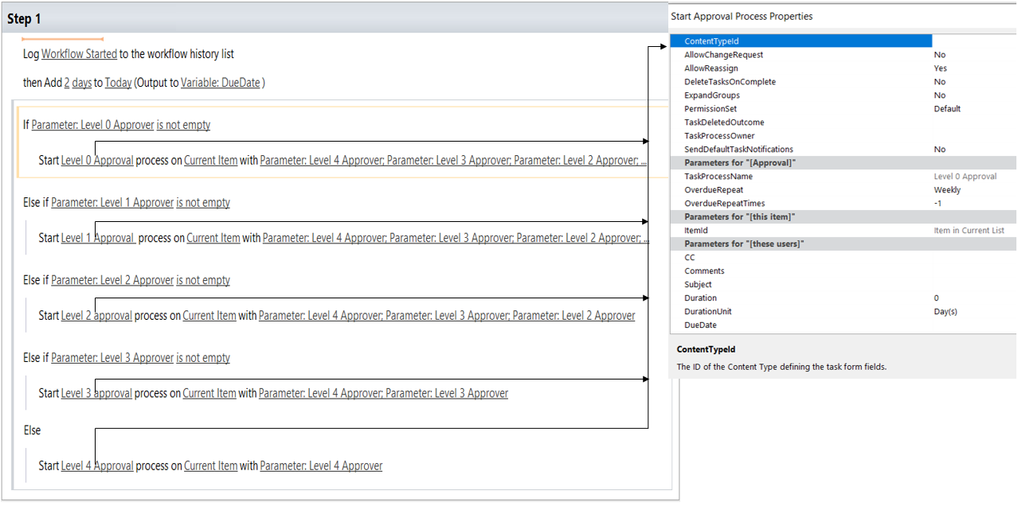

**Power Automate based workflow:**

**WF – 1**

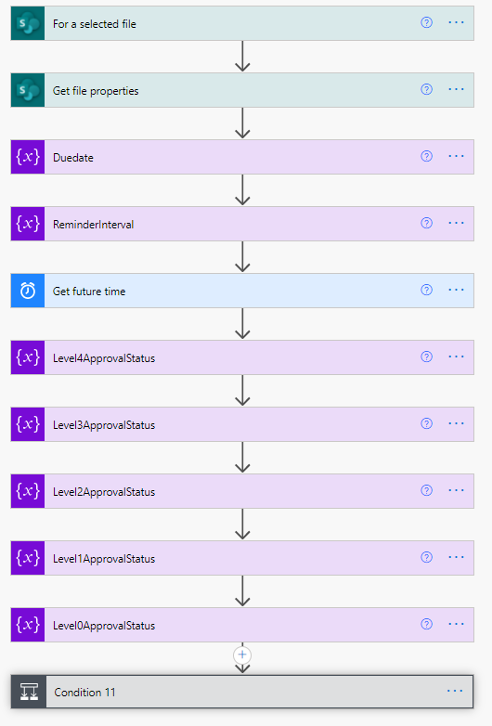

**Power Apps based workflow:**

**WF – 2**

**WF – 3**

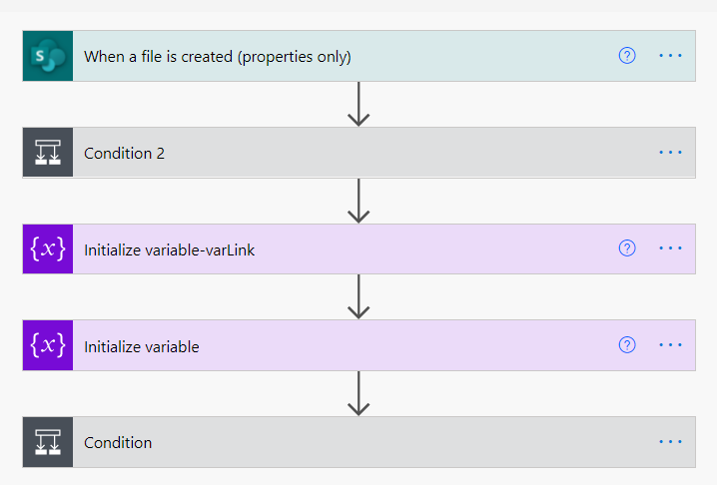

**WF – 4**

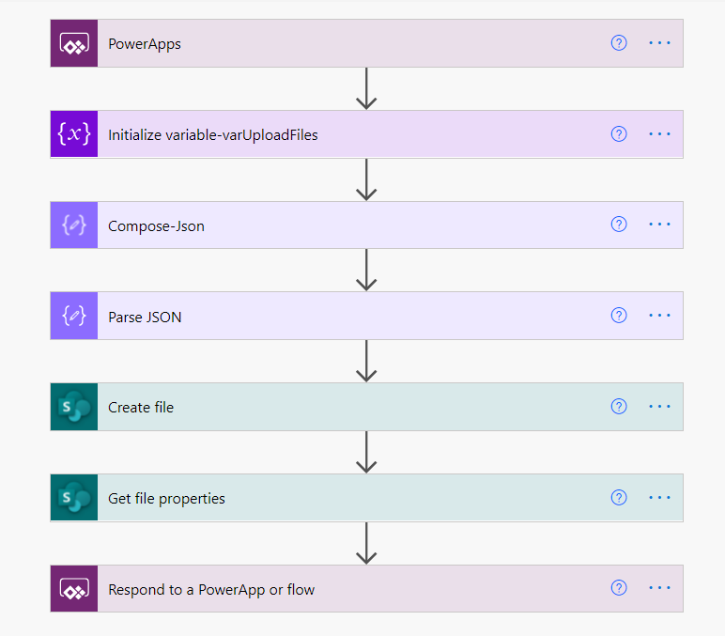

**Attachment:**

You can find which connectors are used in the workflow by importing below ZIP files.

* Power Automate based workflow:



* Power Apps based workflow:

